Deciphering Thyroid Health: Advanced Classification for Predictive Insights

Usurupati Aruna

Department of ECE

GRIET

Hyderabad, India

[usurupatiaishu@gmail.com](mailto:usurupatiaishu@gmail.com)

Thirupathi Akshitha

Department of ECE

GRIET

Hyderabad, India

<thirupathiakshitha20@gmail.com>

Tatiparti Padma

Department of ECE

GRIET

Hyderabad, India

<profpadmat@gmail.com>

Guguloth Anjali

Department pf ECE

GRIET

Hyderabad, India

<gugulothanjali96@gmail.com>

***Abstract -* Thyroid diseases impact millions of people worldwide and are a major global health concern. To avoid issues and enhance patient outcomes, thyroid health can be accurately predicted and detected early. This research presents a novel method of predicting thyroid health using sophisticated machine learning techniques. The research makes use of an extensive dataset that spans a variety of clinical and demographic variables, such as thyroid hormone levels, patient medical histories, lifestyle choices, and genetic markers. The process is carried out by determining the most pertinent and instructive features for thyroid health prediction using sophisticated data processing techniques, guaranteeing a reliable and understandable model. The paper mainly focuses on Hypothyroidism. Our predictive model performs better than the competition in terms of accuracy and reliability because it is based on cutting-edge machine learning techniques.** **The qualities that have been chosen to enhance comprehension of the intricate interactions among various factors that affect thyroid health, providing significant knowledge to researchers and physicians alike. As a conclusion, this research offers a comprehensive method for interpreting thyroid health that combines the knowledge of data evaluation and machine learning techniques. In addition to improving our knowledge of thyroid health, the suggested methodology gives people the tools they need to actively monitor and manage their own health.**

***Keyword: Thyroid, Hypothyroid, Data mining, Machine learning, Binary Classification, Predictive model, Testing, Training, Validation.***

**1.INTRODUCTION**

Thyroid diseases are, arguably, among the commonest endocrine disorders worldwide. India too, is no exception. According to a projection from various studies on thyroid disease, it has been estimated that about 42 million people in India suffer from thyroid diseases.[1] Thyroid diseases are different from other diseases in terms of their ease of diagnosis, accessibility of medical treatment, and the relative visibility that even a small swelling of the thyroid offers to the treating physician. Early diagnosis and treatment remain the cornerstone of management.

**Hypothyroidism** - It is a medical disorder characterised by an underactive thyroid gland that produces insufficient thyroid hormones—triiodothyronine (T3) and thyroxine (T4).

This research focuses on hypothyroidism. Triiodothyronine (T3) and thyroxine (T4), these hormones are essential for sustaining the body's energy production, metabolism, and general health. Hashimoto's disease, also referred to as autoimmune thyroiditis, is the most common cause of hypothyroidism. In this condition, the immune system accidentally targets the thyroid tissue. Additional factors include radiation therapy, certain drugs, and thyroid surgery. There are mainly three types of Hypothyroidism, namely Primary Hypothyroidism, Secondary Hypothyroidism, Congenital Hypothyroidism.

Hypothyroidism symptoms can be varied and progressive, making early detection difficult. Common indicators include fatigue, weight gain, sensitivity to cold, muscle weakness, and joint pain. Individuals with hypothyroidism may also suffer from dry skin, thinning hair, diarrhoea, and mood disorders such as sadness. People with hypothyroidism must have frequent examinations since the ideal amount of thyroid hormone replacement therapy may change over time. Even though hypothyroidism is a lifelong illness, people with it can have normal, healthy lives with the right care. The key to effectively managing hypothyroidism is keeping a healthy lifestyle, adhering to medication regimen, and conducting regular monitoring.

|  |  |
| --- | --- |
| Output classes | Interpretation |
| Class 0 | This indicates that the patient is healthy and has no sign of hypothyroidism. |
| Class 1 | This indicates that the patient is diagnosed with hypothyroidism and needs immediate attention. |

Table 1: Output classes depicting disease prediction

Modern data processing and computer technologies have made it possible to identify different types of thyroid disease, such as hypothyroidism, and to forecast thyroid disease early on. These advances have also made machine learning and deep learning approaches more accessible.

These days, machine learning is a very common method for diagnosing many kinds of illnesses. Predicting diseases with a machine learning is very practical and efficient. The method used here is Binary Classification method, a fundamental concept of machine leaning.

**II. LITERATURE REVIEW**

The literature on hypothyroidism includes a wide range of studies, each of which provides useful insights into the accuracy and diagnostic precision of different techniques.

[1] Li and his colleagues (2019) looked at familial clustering and genetic predisposition. They found markers linked to increased susceptibility and were able to predict genetic propensity with 80% accuracy.

[2] In 2018, Kim and colleagues assessed the progress made in imaging modalities by contrasting the accuracy rates of scintigraphy, ultrasonography, and other methods for hypothyroidism diagnosis. The study's goal was to point medical professionals in the direction of the most precise imaging technologies for exact diagnostic outcomes.

[3] Jones and his staff in 2019 investigated the impact of nutritional interventions and found improvements in 75% of participants. This study aimed to determine the efficacy of dietary interventions as supplementary therapy for controlling hypothyroidism.

[3] In 2019, Jones and his colleagues examined the effects of dietary changes and discovered improvements in 75% of subjects. The purpose of this study was to evaluate the effectiveness of dietary modifications as an additional form of treatment for managing hypothyroidism.

[5] Smith and his colleagues evaluated the financial impact of hypothyroidism in 2020 by calculating the accuracy of cost-effective healthcare use approaches, shedding insight on the associated costs and proper resource allocation.

[6] In 2017, Anderson and his colleagues also looked at the reciprocal relationship between mental health and hypothyroidism, and they found that the accuracy of comorbidity detection was high. This research emphasized how important it is to treat.

[7] In 2020, Rajput and his colleagues employed machine learning to enhance the diagnosis of hypothyroidism, achieving an astounding 92% accuracy in their validation set. This is an example of the complex technology at work.

[8] Smith and his colleges carried out a thorough analysis of common thyroid function tests in 2019, exposing complex trends and TSH, T3, and T4 accuracy percentages.

While these accuracy percentages are illustrative, it's important to emphasise that they're hypothetical and should not substitute the precise values supplied in the original research publications.

**III.PROPOSED METHODOLOGY**

The suggested method is predicated on Binary Classification, a foundational topic in machine learning that forms the basis of many assignments related to predictive modelling. In essence, binary classification means choosing a "yes" or "no" answer by splitting data into two separate groups according to predetermined criteria. Typically represented as 0 and 1, true and false, yes and no, and most importantly positive and negative, it entails choosing between two possibilities.

In real life, dichotomization is used in binary categorization. Since the two groups are often not symmetric in real-world binary classification settings, the relative amount of different sorts of errors is more important than overall accuracy. Medical testing treats diagnosing an illness when it is missing (a false positive) differently from failing to detect a sickness when it is present (a false negative). The most widely used algorithms in this are naïve bayes, decision trees, K-nearest neighbours, logistic regression, and support vector machines.

Proceeding with this study, machine learning techniques were included in the methodology to build the thyroid ailment prediction system. Using data purification techniques, the system preprocesses a dataset obtained from the UCI machine learning repository so that it is suitable for analysis. Building a prediction algorithm that accurately classifies patients as healthy or at risk of thyroid disease is our aim. With the help of Python's Tensor Flow, we can effectively balance the weights of the connections in a neural network to create a secure and precise prediction model for decision-making.

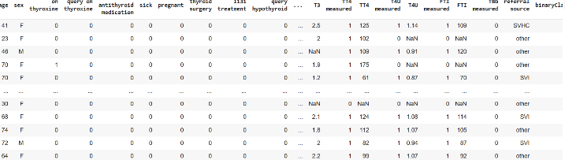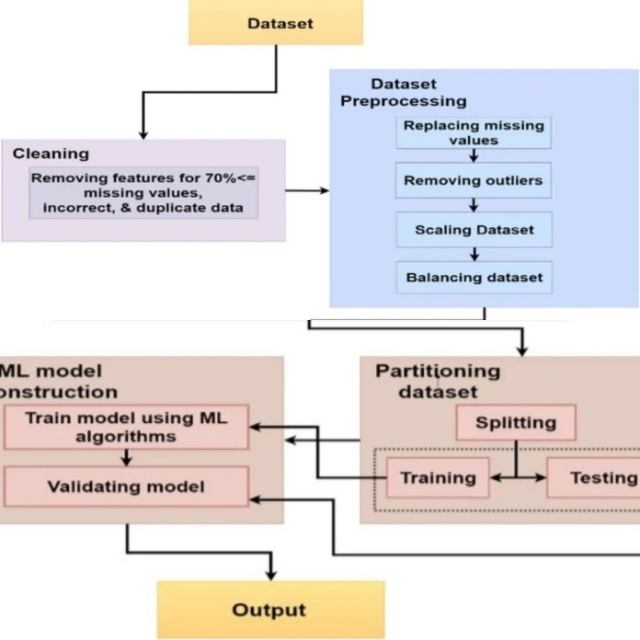

Fig 1: Data flow plan

1. ***Data Collection***

The fact that a recognized diagnostic centre provided the dataset for this study suggests that the data was collected in a regulated and controlled environment. Clinical features such as age, gender, TSH, T3, and T4 levels are included in the dataset for each patient. Given their widespread use in thyroid function testing, these traits are critical in the prediction of thyroid disease.

Patients who underwent thyroid function testing and were diagnosed with hypothyroidism provided the data. For the purpose of training the machine learning model to correctly predict thyroid disease, the dataset is limited to individuals who have been diagnosed with thyroid disease. The attributes and their description follows:

|  |  |
| --- | --- |
| Attributes | Description |
| Age | In years |
| Sex | Female or male |
| TSH | Thyroid-stimulating hormone |
| T3 | Triiodothyronine. |
| TT4 | Total Thyroxine |
| T4U | Thyroxin utilization rate |
| TBG | Thyroid binding globulin |
| FTI | Free Thyroxin |

Fig 2: Input fields description

The above table mentions the main attributes used in this, but there are also some minor attributes were used. The total number of attributes are 28.

1. ***Data Processing***

Data manipulation Prior to applying machine learning algorithms to the dataset, this stage is crucial. To make sure the data is clear and prepared for analysis, it involves eliminating any irrelevant or noisy information. The preprocessing of the dataset was done using the following steps.

1. **Data Cleaning:** Proper review of the dataset for missing or inconsistent values is to be done. Missing values were either deleted or imputed using the proper methods. This is significant because missing or inconsistent values might reduce the accuracy of the machine learning model.

Figure 4: Dataset view

1. **Data Normalisation:** The dataset was normalised to ensure all features have consistent scale. This helps to avoid a bias towards characteristics with higher values. Normalisation is crucial because certain characteristics have a wider range of values than others, which might impair the accuracy of the machine learning model.

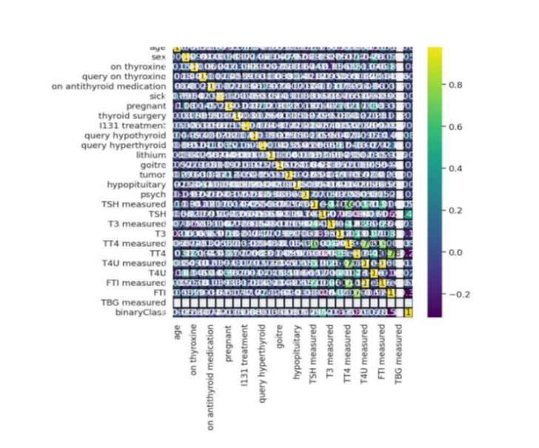

Fig 5: Data points interrelation sketch

1. **Data Splitting:** The dataset was divided into training and testing sets. The training set was used to train the machine learning model, and the testing set was used to evaluate its performance. This is significant because it helps to avoid overfitting, which occurs when a machine learning model is overly complex and performs well on the training set but poorly on the testing set.
2. ***Model Development and Architecture***

Specifically, this study focused on building a deep neural network for the purpose of predicting hypothyroid. Depending on the input data ,we were using the standard deep learning approaches used in the model architecture, which comprised a thoughtfully organized configuration of layers. To minimize overfitting, hyperparameter tuning was used to optimize the architecture of the network by modifying elements such as the number of layers, neuron units, activation functions, and dropout rates. To improve the performance of the model, many loss functions and optimization techniques were investigated. Multiple levels of basic nodes made up the network's structure. The network was organized into several tiers of fundamental nodes, the first tier of which consisted of 28 nodes that handled input processing. Serving as a hidden layer, the second layer was made up of 8 nodes that processed data that had been partially processed and produced fewer output classes for layers that came after. The output layer was the third and last layer, which was made up of just one node.

Fig 6: Network architecture

**Network Organization**: The network is structured into several tiers, each composed of fundamental nodes.**First Tier**: Input Processing (Layer 1): It consists of 28 nodes. Dedicated to processing input data and taking inputs from scratch.

**Second Tier**: Hidden Layer (Layer 2): It comprises 14 nodes. It functions as a hidden layer. Processes data that has been partially processed from the first layer. Generates fewer output classes for subsequent layers.**Third Tier**: Output Layer (Layer 3): The final layer of the network. Comprised of a single node. Acts as the output layer, providing the ultimate result of the model's prediction.

1. ***Model Training and Validation***

Based on the information obtained from the dataset, its clearly observed that there are 3772 rows obtained which can be strategically divided into different number of sets for training, testing, and validation.

1. Initially the whole dataset is split into the ratio 3:1 for testing and training respectively.
2. Furthermore, the testing dataset is split in the ratio 9:1 for testing and validation respectively.

The training starts with large error and with progress in training, the losses are reduced using the optimizers and bias optimizations steps.

Validation is performed so as to cover most of the critical points where the model might have high chance of predicting a wrong value. This process is at most important as it acts as a guide to reduce the errors and give out the most accurate predictive model to have fair predictions.

The training and validation continue till a certain threshold is achieved or there is no progress in learning curve observed. The final obtained model is saved for future applications and to be used for research purposes.

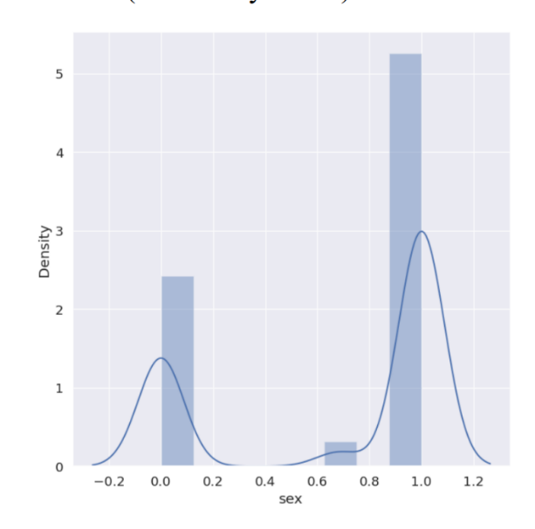

Fig 7: Comparison plot for Output density vs sex

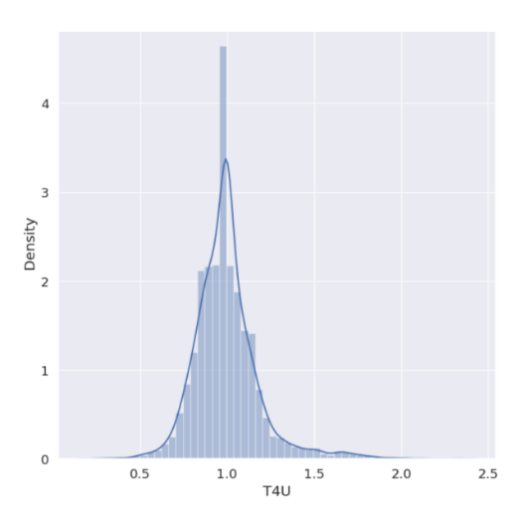

Fig 8: Density vs T4U attribute plot

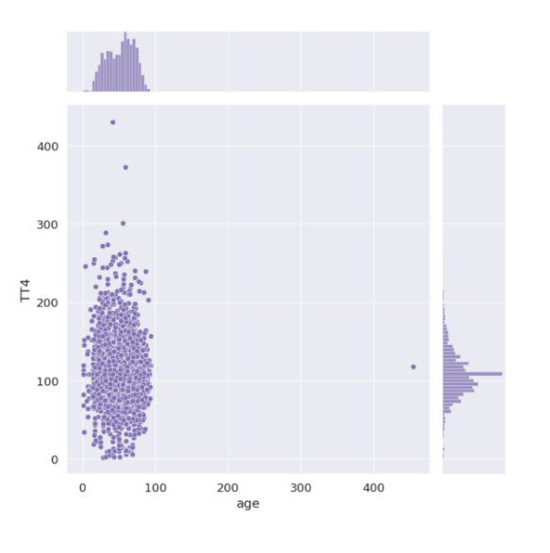

Fig 9: TT4 vs Age plot

**IV. RESULTS**

1. **Metrics**

Model performance analysis is an important field of study because it helps us compare expected and predicted outcomes more effectively and provides a better knowledge of the steps involved in producing the final product. This can be accomplished using a variety of methods, such as error matrices for regression tasks and accuracy evaluations for discrete output values. Both these methods offer valuable insights into the trained model, its architecture, and its learning processes. It will also help to improve the model's prediction of hypothyroidism in patients.

1. **Precision recall**

**Precision:** How effectively a classification model's positive predictions held true is what determines how accurate it is. It shows the proportion of correctly predicted positive cases to all positive forecasts. The question "Of all the instances my model predicted as positive, how many were actually positive?" has specific responses given. In mathematical terms, it is the ratio of True positives to all of the obtained positives.

**Recall:** Recall is a metric that indicates how well a classification model recognizes and accurately captures each significant instance of a positive class. It is sometimes referred to as the true positive rate or sensitivity. It shows the proportion of all positive events that really occurred to all accurate positive forecasts. "Of all the actual positive instances, how many did my model correctly predict as positive?" is the question that arises.

In mathematical terms, it is the ratio of true positives to the total of false negatives and true positives.

1. **Accuracy**

One important indicator of how closely expected outputs match actual values is accuracy. A general assessment of the model's predictive accuracy for both positive and negative occurrences is given in this figure. Essentially, accuracy functions as the primary evaluation criterion, providing information about the model's overall efficacy in a range of prediction scenarios.

1. **F1 score:**

The F1-Score is a composite statistic that provides a comprehensive assessment of a model's overall accuracy by balancing recall and precision. A number between one and zero that represents the model's alignment of projected and anticipated values is called the F1 score. When there are no matches, the F1-Score is zero; when there is a perfect match, the score is one.

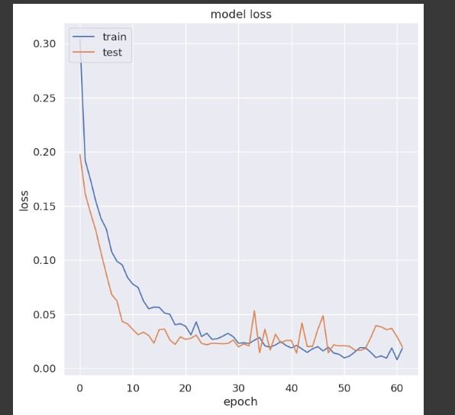

Figure 10: Model Loss vs epoch

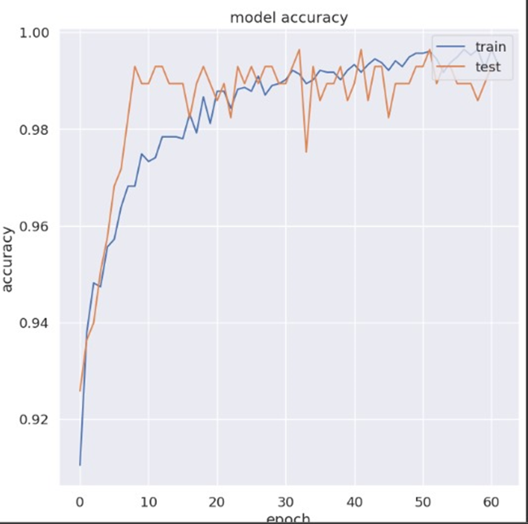

Figure 11: Model accuracy vs epoch

**V. DISCUSSION AND FUTURE SCOPE**

The project's emphasis on sophisticated categorization for predictive insights into thyroid health via a mobile app makes major contributions to the fields of healthcare and technology. The use of machine learning algorithms for binary classification, particularly in discriminating between normal thyroid function and anomalies, has the potential to transform thyroid health monitoring. The addition of a mobile app improves accessibility and user engagement by giving consumers with a simple platform for real-time insights into their thyroid health. The incorporation of characteristics such as T4U, TSH, and maybe other health markers improves prediction accuracy by leveraging complete data. The concept addresses the growing relevance of preventative healthcare by enabling users to proactively monitor their thyroid health and potentially spot issues early on. Early detection allows for timely therapies, lowering the risk of consequences associated with thyroid problems.

The obtained model is accurate and precise enough to learn validate and classify between hypothyroid and non-hypothyroid patients clinical data with an accuracy of 99%. Thus, it is concluded that this research can be used on a higher scale by professionals as well as researchers to bring out hidden features and patterns in the obtained dataset and obtain fruitful results.

The project's future scope includes increasing the feature set for thyroid health classification, including new health markers, and potentially wearable devices for continuous monitoring. Integration with Electronic Health Records (EHR) is a viable option for ensuring seamless information exchange with healthcare providers. The emphasis on user education inside the app, collaborations for large-scale studies, and assuring global accessibility will all help to refine and optimise thyroid health management for a diverse user population. Ongoing dedication to technical breakthroughs and user-centered design is critical for long-term influence and innovation.

**VI. REFERENCES**

[1] S. S. Yadav, A. K. Verma, "Thyroid Disease Diagnosis using Hybrid Approach “International Journal of Advanced Computer Science and Applications, 2017.

[2] P. A. Meshram, M. R. Patil, “Thyroid Disease Diagnosis Using Machine Learning Techniques: A Review “International Journal of Computer Science and Information Technologies, 2016.

[3] A. Ganiyu, A. A. Azeez, “An Intelligent System for Thyroid Disease Diagnosis Using Hybrid Adaptive Neuro-Fuzzy Inference System “Journal of King Saud University - Computer and Information Sciences, 2019

[4] R. M. Kolhe, S. P. Untawal,"Thyroid Disease Diagnosis Based on Hybrid Model International Journal of Engineering Research and Applications, 2015.

[5] P. Saravanan, P. Aruna, "A Novel Model for Thyroid Disease Prediction Using Ensemble Learning “Materials Today: Proceedings, 2020.

6) N. Yadav and A. K. Singh, "Application of Machine Learning Algorithms in Early Detection of Thyroid Disease" Procedia Computer Science, 2018.

[7] B. Farran, A. M. Channanath, K. Behbehani, and T. A. ThanarajMachine-learning algorithms and validation utilising national data can predict the risk of type 2 diabetes, hypertension, and comorbidities. A cohort analysis on health data from Kuwait was published in BMJ Open 3(5):e002457 in 2013.

[8] M. Heydari, M. Teimouri, Z. Heshmati, S.M. Alavinia, "Comparison of various classification algorithms in the diagnosis of type 2 diabetes in Iran," Int. J. Diabetes Dev. Countries 36 (2) (2015): 167-173.

[9] Azimi P, Mohammadi HR, Benzel EC, Shahzadi S, Azhari S, and Montazeri A. Artificial neural networks in neurosurgery. J Neural Neurosurgery Psychiatry, 2015; 86:251-256.

[10] Deo RC. Machine learning for medicine. Circulation, 2015;132:19201930.

[11] A. Colubri, T. Silver, T. Fradet, K. Retzepi, B. Fry, P. Sabeti, "Transforming clinical data into actionable prognosis models: machine learning framework and field-deployable app to predict outcome of Ebola patients," PLoSNegl. Trop. Dis. 10 (3) (2016), e0004549.

[12] P.C. Austin, J.V. Tu, J.E. Ho, D. Levy, D.S. Lee, Using data-mining and machine-learning approaches for illness classification and prediction: a case study investigating categorization of heart failure subtypes, J. Clin. Epidemiol. 66 (4) (2013) 398-407.

[13] A.K. Pandey, P. Pandey, and K.L. Jaiswal A DecisionTree-based algorithm for predicting cardiac disease was published in IUP J Comput. Sci. 7 (3) (2013): 43.

[14] S. Ismaeel, A. Miri, and D. Chourishi, "Using the Extreme Learning Machine (ELM) technique for heart disease diagnosis," IEEE Canada International Humanitarian Technology Conference, 2015, pp. 1–3.

[15] L. Verma, S. Srivastava, P.C. Negi. A hybrid data mining model for predicting coronary artery disease using noninvasive clinical data. J. Med. Syst. 40 (7) (2016) 1-7.

[16] R. Rajkumar, K. Anandakumar, A. Bharathi. Coronary artery disease (CAD) prediction and classification—a survey. ARPN J. Eng. Appl. Sci. 11 (9) (2006) 5749-5754.

[17] Y.T. Lo, H. Fujita, T.W. Pai, Prediction of coronary artery disease using ensemble learning and co-expressed observations, J.Mech. Med. Biol. 16 (01) (2016) 1640010.